3. Physical Topology
The proposed physical design uses a access structure with a Layer 3 core switch, two access switches, a primary router, a backup router, and two ISP/Internet representations.
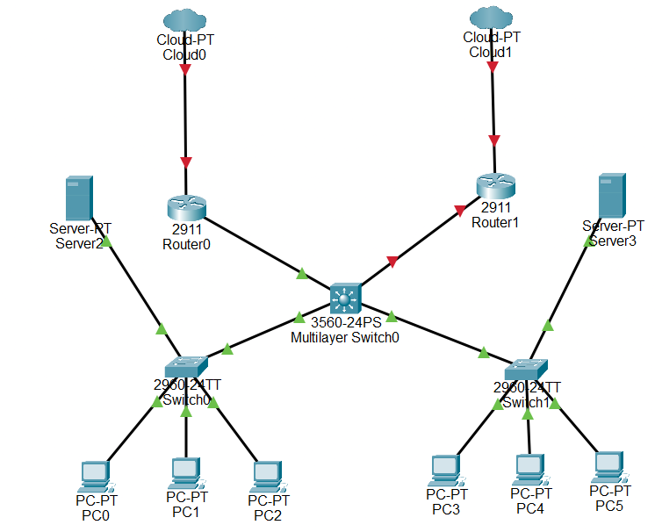
3.1 Proposed Packet Tracer Devices
Device | Quantity | Purpose
Core Switch | 1 | Inter-VLAN routing and central connectivity
Access Switch | 2 | Connect departmental end devices
Primary Edge Router | 1 | Primary Internet connection
Backup Edge Router | 1 | Backup Internet path
ISP/Cloud representation | 2 | Primary and backup Internet paths
PCs/end devices | As required | Department users
Servers | As required | Network/business services

3.2 Physical Connection Principle
Core switch Access Switch 1: 802.1Q trunk
Core switch Access Switch 2: 802.1Q trunk
Core switch Primary router
Core switch Backup router
Access switches PCs/end devices using access ports

